Ex. No:6 Use Sleuth Kit to Analyse Digital Evidence
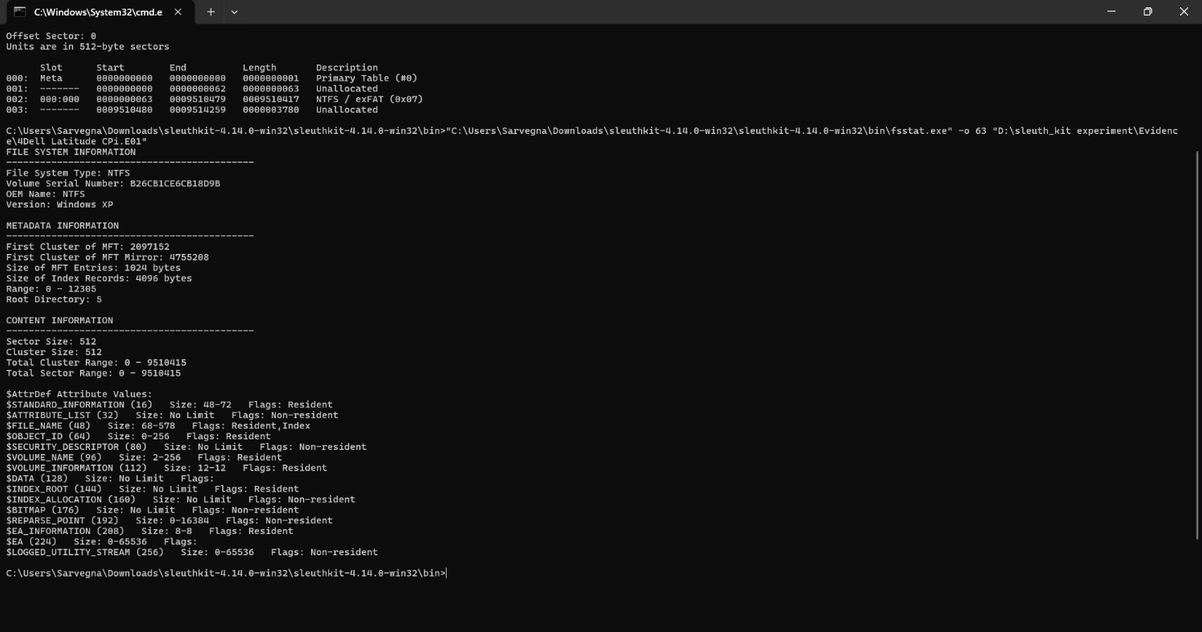
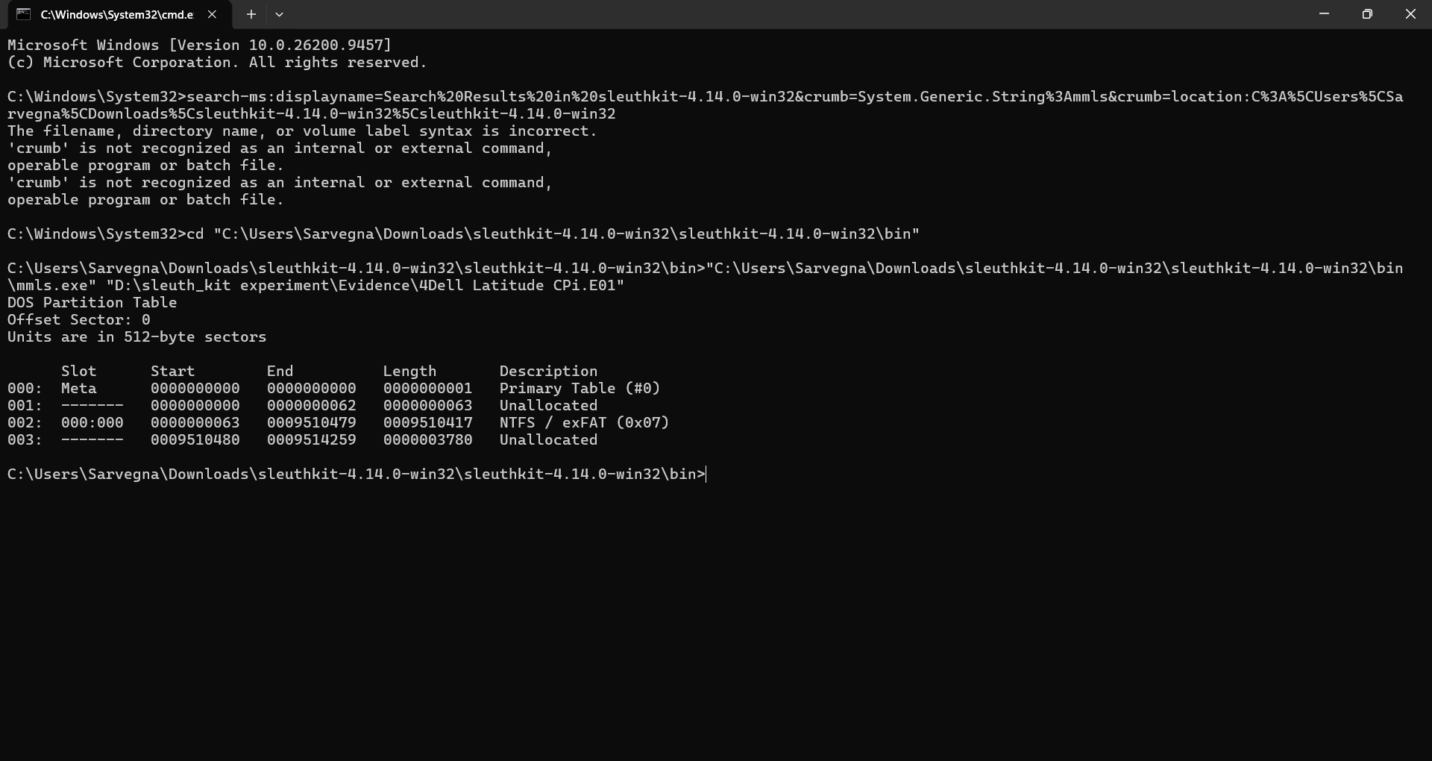
Outcome:
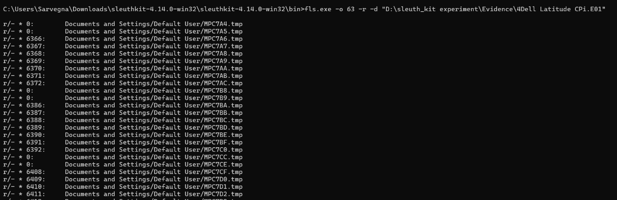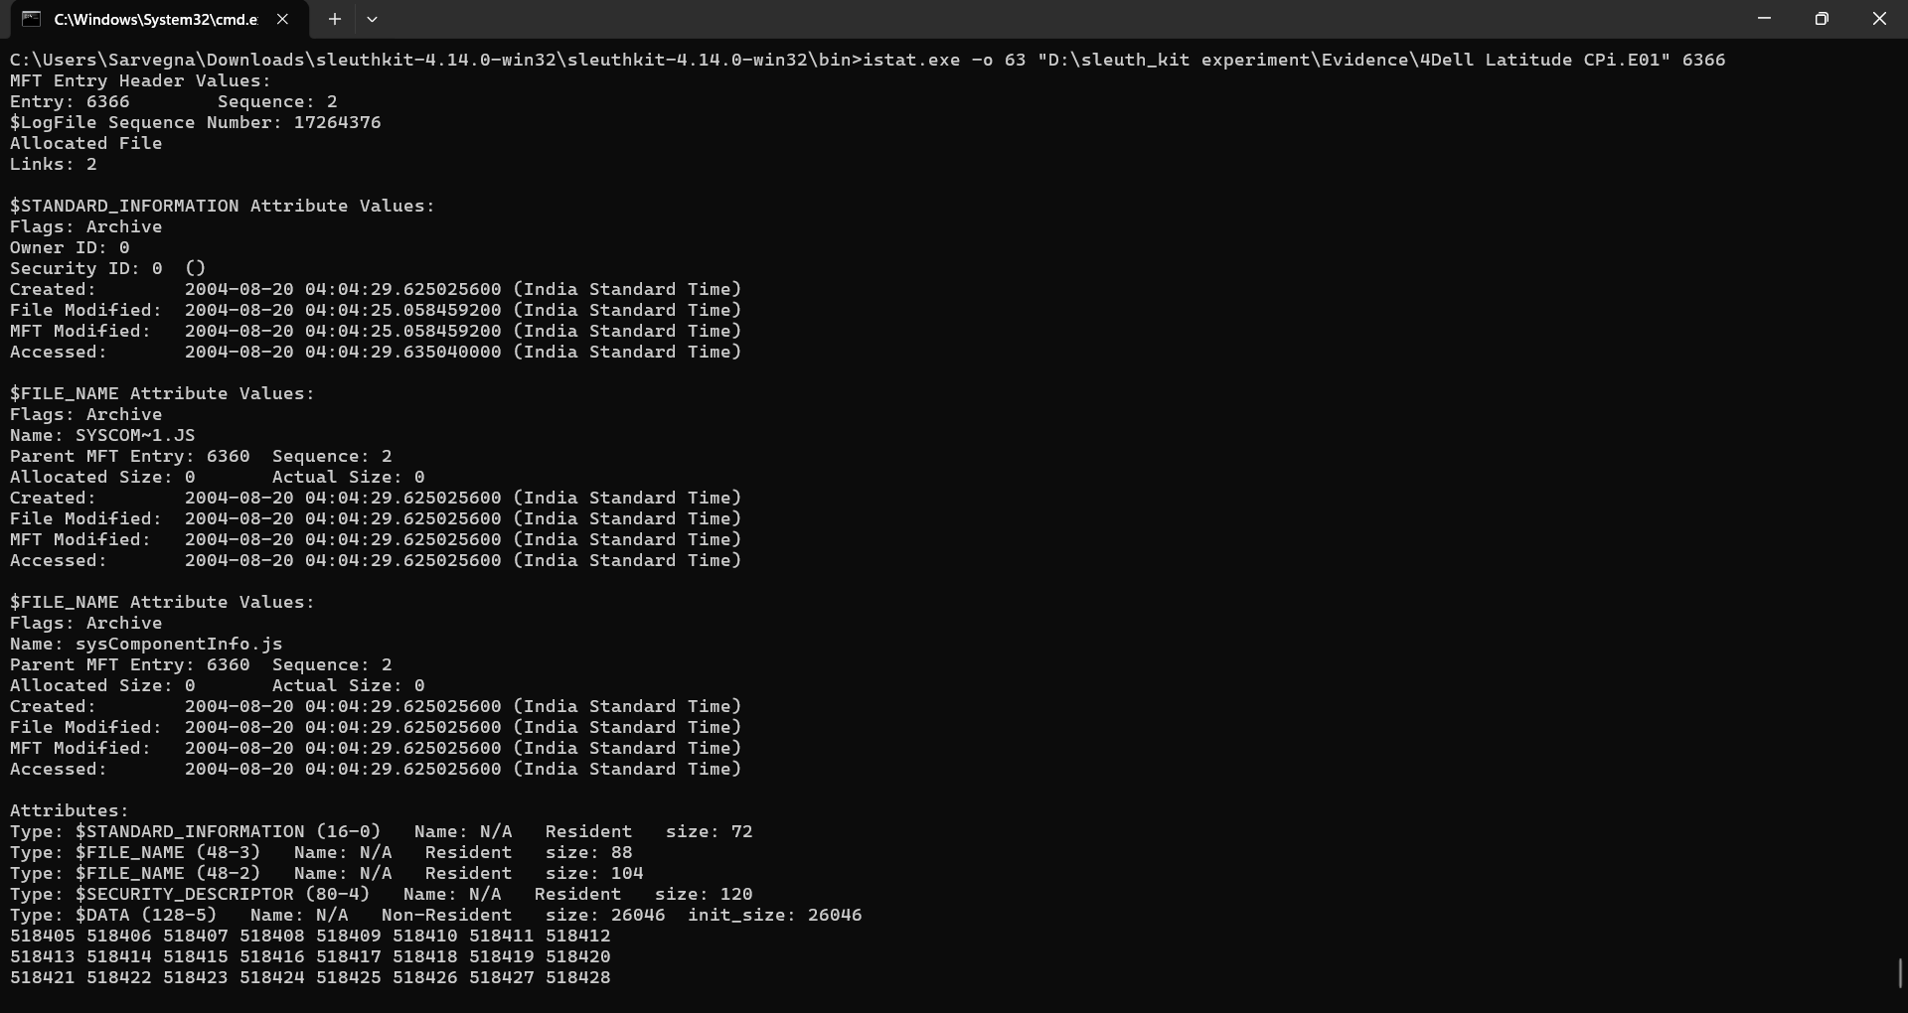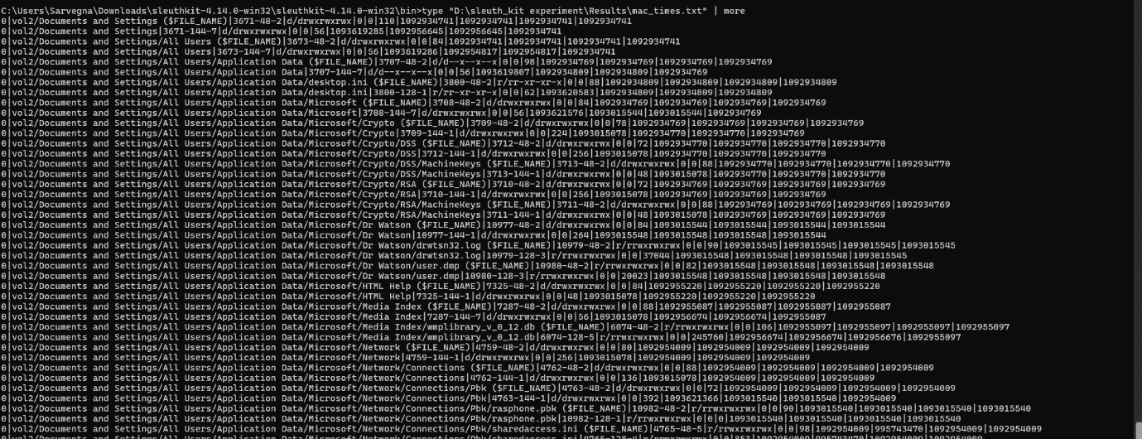

Result: The forensic disk image was successfully analysed using Sleuth Kit. Partition and file-system information, file listings, deleted entries, metadata, a recovered file, and MAC-time information were successfully obtained from the evidence image.

